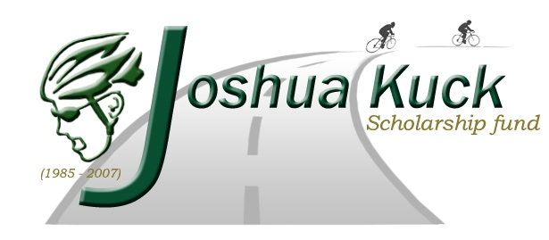
The Joshua Kuck Scholarship Fund at USA Cycling Development Foundation is having a dollar fundraiser.
We need your help to raise money to award to collegiate cyclists who promote cycling safety.
Would you please help and sign any line for a dollar?

1. I will start you off. ______________________________________________
2. I’m happy to give you a dollar. ____________________________________
3. A dollar won’t break me. ________________________________________
4. A dollar is not very much. ________________________________________
5. I just can’t say no. ______________________________________________
6. Well since it’s you. _____________________________________________
7. What’s a dollar between friends? ___________________________________
8. I’ll gladly give you a dollar! _______________________________________
9. My dollar is for a good cause. _____________________________________
10. My dollar helps reach the goal. ___________________________________
11. I wish I could give more. ________________________________________
12. What’s one less in my wallet? ____________________________________
13. Count on me for a dollar! _______________________________________
14. Sure, I’ll give you a dollar! ______________________________________
15. I’m always glad to help. ________________________________________
16. I can’t say no to a friend. _______________________________________
17. A dollar from me to you! _______________________________________
18. Don’t leave me out! ___________________________________________
19. I can’t spend more than $1.00. ___________________________________
20. I borrowed this for a good cause! ________________________________
21. One more for you! ___________________________________________
22. Will $1.00 help? ______________________________________________
23. I'm happy to give a buck! _______________________________________
24. Add this to your pile! __________________________________________
25. YAHTZEE, you’re #25! ________________________________________

Thank you for your support!
Complete a “Can You Spare a Dollar?” sheet by collecting $25 from friends and family. Prizes will be awarded to the participant who completes the most sheets. Bring your completed fundraising earnings to the ride registration table on Saturday 8/29/2009.

Or donate online at www.usacdf.org. Click on Donate Online Today, and make your contribution to the Kuck Scholarship Fund!

